The University of South Wales Guide to
Numeric Referencing
Using Royal Society of Chemistry style

Revised edition July 2019

Contents

Acknowledgement 2
Introduction 2
What is referencing? Why reference?
Plagiarism – academic integrity Help
How to Reference 3
The Basics
Citing within the text Quoting
Adding notes/footnotes Listing references Bibliography list

How to reference books 6
Book with single author
Book with two or more authors Book with editor(s)
Chapter in an edited book Book with corporate author Book usually known by its title E-book
E-book via an e-book reader such as Kindle

How to reference journals 9
Printed journal article
Journal article from a subscribed database
e.g. Science Direct
Journal article from an internet journal Journal article from an open access journal
How to reference newspapers 10
How to reference the internet 10
Web pages with individual authors
Web pages with organisations as authors Blogs
Wikis

How to reference – miscellaneous 12
Conferences Patents
Other reports/Government publications Standards
Theses

How to reference legal material 13
Cases Statutes

How to reference visual material 14
Figures, illustrations,
graphs, maps, charts and tables

Introduction to referencing

Acknowledgement
This guide is based on the Royal Society of Chemistry’s Publishing ‘Author guidelines’ available at http://www.rsc.org/images/Author_guidelines_tcm18- 186308.pdf

Introduction
The aim of this guide is to help you correctly reference using a numeric style of referencing when writing assignments. It highlights examples from some of the most popular types of sources, and illustrates the conventions involved when citing these sources. As a student studying chemistry and forensic science, you should follow the examples set out in this guide.
However, if you are also studying modules from other disciplines, you will need to check the appropriate referencing system for these.

What is referencing?
Referencing is indicating in assignments when you have used material that has not originated with you. This might include factual information, data, images, opinion, direct quotation, or when you summarise or paraphrase the work of other people.

Why reference?
In most academic assignments your ability to understand, analyse and evaluate the work of others is being measured. Consequently, referencing is a crucial part of this as it informs the reader of the texts you have consulted during research; you will also be assessed on the quality and relevancy of these sources. It is important to remember that referencing carries a percentage of the overall marks if undertaken appropriately.
Plagiarism – academic integrity
This section is based on the University guide to academic integrity, available on UniLife.

A key element of academic integrity is understanding good academic practice in written work and creative practice. Understanding how to use the work of other scholars, including your peers, to develop your own insights into a subject is an important professional skill.

You will be expected to follow professional academic conventions. Within the international academic community it is never acceptable to use the words of others or their creative output (whether published or unpublished, including material from the internet) without explicit acknowledgement. To do so would not be seen as a mark of respect but rather as plagiarism.

When you take notes from sources, make sure you do so in ways which identify where you are recording your own observations based on the document you are reading, where you are paraphrasing and where you are recording direct quotations. This will be particularly important if you are taking notes over a longer period and then reviewing them later. For more information on how to give credit to others’ work that influences your own

Help
Please seek advice from your lecturer, the Student Development and Study Skills Service or your Information Librarian if you need further guidance.

How to reference

The basics
There are two essential requirements for incorporating references into your work when using a numeric referencing system:
- use a superscript number in the text.
- provide an accompanying numbered list of references at the end of the assignment.

EXAMPLE: Citing within the text

Blood alcohol concentrations may need to be measured when an individual has been charged with committing an offence under the influence of alcohol. Blood analysis may occur several hours after the incident, thus requiring the forensic scientist to estimate the alcohol concentration at the time the incident took place, a process defined as back- calculation.1
.......Calculation is simplified when no post-incident alcohol consumption has occurred.1 The forensic scientist could be called as an expert witness to explain the calculation in a court of law.....
.......Calculation can be complicated when post-incident alcohol consumption has taken place, however, Barbour2 demonstrates how this can be simplified by adopting the corrective factor known as the Widmark value.
......Sustained alcohol abuse may result in little or no blood alcohol present at autopsy but the use of biochemical markers as an alternative to using liver histology could be employed as a method of diagnosing chronic alcoholism.3,4 Ketoacidosis often occurs in the alcohol abuser, with a level of acetone exceeding 7mg per 100mL being a good indicator of sustained alcohol misuse.1

References at the end of the assignment:

1. A. Langford , J. Dean, R. Reed, D. Holmes, J. Weyers and A. Jones, Practical Skills in Forensic Science, Pearson Education Limited, Harlow, 2005.
2. A.D. Barbour, Sci. Justice., 2001, 41(1), 53-54.
- D.W. Sadler, E. Girela and D.J. Pounder, Forensic Sci. Int., 1996, 82(2), 153-163.
- F.C. Kugelberg and A.W.Jones, Forensic Sci. Int., 2007, 165(1), 10-29.

Citing within the text
As can be seen from the example, superscript numbers are used to ‘cite’ the references in the main body of text and refer the reader to a numerical sequence of references positioned at the end of your work.

  - The in-text superscript number should be inserted after the full stop, or after the word or phrase to which it relates. You do not need to wait until the end of the paragraph to cite.

  - A superscript number can be created by typing a number and highlighting it, then clicking on Format / Font / Superscript; alternatively use this if available on your tool bar.
• The numbering of the references corresponds to the
first time you refer to the source.

- Importantly, as in the previous example, the first reference is used more than once, but it is not given a new number. This is because it only needs to appear once in the list of references at the end of the assignment, even if you are referring to it several times in the text.

- If the information you refer to in your sentence(s) has come from several sources you must cite all of them, for example:

EXAMPLE : Citing within the text
It has been shown, however, that the research in this area is inconclusive5,6-10 even though Barbour2 further declared ….

Quoting
When you are directly quoting from a source, use quotation marks “ ” for a short quote of less than three lines or indent it if it is a longer quote.

EXAMPLE : Short Quotation

Mc Goldrick, Marzec, Scully and Draper1 argue that in the absence of meaningful student engagement “ teaching chemistry can descend to the dry delivery of chemical facts”.

Reference at the end of the assignment:

1. N.B. Mc Goldrick, B. Marzec, P.N. Scully and S.M. Draper, J. Chem. Educ., 2013, 90(3), 338.

EXAMPLE: Long Quotation

Soil and other earth materials have been used as admissible evidence in most jurisdictions for many years.

The value of soil as evidence rests with its prevalence at crime scenes and its transferability between the scene and the criminal. Thus, soil or dried mud found adhering to a suspect’s clothing or shoes or to an automobile, when compared to soil samples collected at the crime site, may link a suspect or object to the crime scene.1

Reference at the end of the assignment:

1. R. Saferstein, Criminalistics: An Introduction to Forensic Science, Pearson Education, Boston, Mass., 10th edn., International edn., 2011, ch. 4, p. 111.

Adding notes/footnotes
Material which is too extensive or would disrupt the flow of your argument, may be inserted into either a footnote or an endnote. Footnotes are referred to with the following symbols: †, ‡, §, ,¶. Endnotes appear in the references section of the manuscript. The notes should be numbered using the same numbering system as the bibliographic references.

List of References
Each reference begins with the number that has been attributed to it within the text. The references are listed in numerical order (NB: if a number appears more than once within the text, it only needs to appear once in the references). In your reference list, ALL authors’ / editors’ names are included in each entry; they must not be replaced by the phrase et al.

Journal titles are given in the abbreviated form using the style defined in Chemical Abstracts Service Source Index (CASSI). Please consult the CAS Source Index (CASSI)search tool: http://cassi.cas.org/search.jsp. Where the abbreviated journal title cannot be found cite the full title.
Bibliography list
There may be items which you have consulted for your work, but not cited. These can be listed at the end of your assignment in a ‘bibliography’. These items should be listed in alphabetical order by author’s family name and laid out in the same way as items in your reference list.

How to reference books

Book with a single author

Reference example:
P. Atkins, Elements of Physical Chemistry, Oxford University Press, Oxford, 6th edn., 2013.
Reference order:
- INITIALS, Author surname
- Title (in italics)
- Publisher
- Place of publication
- Edition (if not the first)
- Year
- Chapter number if relevant
- Page reference if relevant

Book with two or more authors

Reference example:
R. Lewis and W. Evans, Chemistry, Palgrave Macmillan, Basingstoke, 4th edn., 2011, pp. 38-39.

A. Langford, J. Dean, R. Reed, D. Holmes, J. Weyers and
A. Jones, Practical Skills in Forensic Science, Pearson Education Limited, Harlow, 2005.
Reference order:
- INITIALS, Author(s) surname(s)
- Title (in italics)
- Publisher
- Place of publication
- Edition (if not the first)
- Year
- Chapter number if relevant
- Page reference if relevant

Book with editor(s)

Reference example:
Handbook of Criminal Investigation, ed. T. Newburn, T. Williamson and A. Wright, Willan Publishing, Cullompton, 2007.
Reference order:
  - Title (in italics)
  - ed. INITIALS, editor(s) surname(s)
  - Publisher
  - Place of publication
  - Edition (if not the first)
  - Year
  - Page reference if relevant

Chapter in an edited book

Reference example:
D. Halliday, in Crime Scene to Court: the Essentials of Forensic Science, ed. P. White, Royal Society of Chemistry, Cambridge, 3rd edn., 2010, ch.10, pp.272-281.

N.B If you are referring to a particular book chapter or range of pages in a book, add the chapter and page numbers at the end of the reference.
Reference order:
- INITIALS, Surname of author of the chapter
- in
- Title (in italics)
- ed. INITIALS, editor(s) surname(s)
- Publisher
- Place of publication
- Edition (if not the first)
- Year
- Chapter number if relevant
- Page reference if relevant

Book with corporate author

Reference example:
American Chemical Society, Chemistry in the Community,
W.H. Freeman, New York, 5th edn., 2006.
Reference order:
- Corporate author
- Title (in italics)
- Publisher
- Place of publication
- Edition (if not the first)
- Year
- Chapter number if relevant
- Page reference if relevant

Book usually known by its title

Reference example:
Merck Index, Royal Society of Chemistry, Cambridge, UK., 15th edn., 2013.

Reference order:
- Title (in italics)
- Publisher
- Place of publication
- Edition (if not the first)
- Year
- Chapter number if relevant
- Page reference if relevant

E-book

Reference example:
J.A. Joule and K. Mills, Heterocyclic Chemistry, 5th edn., [e-book], John Wiley & Sons Ltd., Chichester, 2010 [cited 15 March 2013]. Available from: Dawsonera. http://www.dawsonera.com.
Reference order:
- INITIALS, Author surname
- Title (in italics)
- Edition (if not the first)
- [e-book]
- Publisher
- Place of publication
- Year
- [cited dy mth yr]
- Available from:
- Name of e-book collection
- URL

E-book via an e-book reader such as Kindle

Reference example:
J. Fraser, Forensic Science: A Very Short Introduction, [Kindle version], Oxford University Press, Oxford, 2010 [cited 19 March 2013]. Available from: http://www.amazon.com.
Reference order:
  - INITIALS, Author surname
  - Title (in italics)
  - [Kindle version]
  - Publisher
  - Place of publication
  - Year
  - [cited dy mth yr]
  - Available from:
  - URL from where the book was downloaded

How to reference journals

*Journal titles are given in the abbreviated form using the style defined in Chemical Abstracts Service Source Index (CASSI). Please consult the CAS Source Index (CASSI) search tool: http://cassi.cas.org/search.jsp
Where the abbreviated journal title cannot be found cite the full title.
Where page numbers are not yet known, articles should be cited by DOI (Digital Object Identifier).

Printed journal article

Reference example:
H.D. Sheets, P.J. Bush and M.A. Bush, J. Forensic Sci.,
2013, 58(1), 60-68.
Reference order:
- INITIALS, Author(s) surname(s)
- Title of journal (abbreviated*)
- Year
- Volume
- (Issue)
- Pages

Journal article from a subscribed database e.g. ScienceDirect

Reference example:
  - Craciun, M-F. Reyniers and G.B. Marin, J. Catal., 2012,
294, 136-150.
Reference order:
- INITIALS, Author(s) surname(s)
- Title of journal (abbreviated*)
- Year

Volume
- (Issue)
- Pages

Article from an internet journal

Reference example:
B. Ganisl and K. Breuker, Does Electron Capture Dissociation Cleave Protein Disulfide Bonds? ChemistryOpen, [Internet], 2012, [cited 20 March 2013], 1(6), 260-268. Available from: http://onlinelibrary.wiley.com/.
Reference order:
- INITIALS, Author(s) surname(s)
- Title of article
- Title of journal (abbreviated*)
- [Internet]
- Year

Volume
- (Issue)
- Pages
- Name of collection
- Available from:
- URL of collection

Article from an open access journal

Reference example:
M. Nilsson, S. Norlin and M. Allen, Sequencing of mtDNA in Shed Hairs: A Retrospective Analysis of Material from Forensic Cases and a Pre-screening Method. Open Forensic Sci. J.,[Internet], 2012, [cited 20 March 2013], 5, 13-22. Bentham Open. Available from: http://www.benthamscience.com/open/toforsj/index.htm.
Reference order:
- INITIALS, Author(s) surname(s)
- Title of article
- Title of journal (abbreviated*)
- [Internet]
- Year

Volume
- (Issue)
- Pages
- Name of collection
- Available from:
- URL of collection

How to reference newspapers
Newspapers (print version)

Reference example:
J. Carvel and D. Pallister, Maguire case may change forensic rules, The Guardian, 13 July 1990, p. 24.
Reference order:
  - INITIALS, Author(s) surname(s)
  - Title of article
  - Newspaper name
  - Date
  - Pages

How to reference the internet

Web pages with individual authors

Reference example:
A. Alden, Chemical weathering, [Internet], 2013 [cited 7 May 2013], [1 screen]. Available from: http://geology.about.com/od/glossaryofgeology/g/defche mweathering.htm.
Reference order:
- INITIALS, Author(s) surname(s)
- Title of the website (or document)
- [Internet]
- Year the site was published/last updated
- [cited dy mth yr]
- [Number of screens or pages]
- Available from:
- URL address

Web pages with organisations as authors

Reference example:
Royal Society of Chemistry, RSC response to the Select Committees Enquiry on strategically important metals, [Internet], 22 December 2010 [cited 7 May 2013], [1 screen]. Available from: http://www.rsc.org/ScienceAndTechnology/Policy/Docume nts/strategic_metals.asp.

NB. For web pages where no author can be identified, please use the title of the web page.
Reference order:
- Organisation name
- Title of the website (or document)
- [Internet]
- Year the site was published/last updated
- [cited dy mth yr]
- [Number of screens or pages]
- Available from:
- URL address

Blogs

Reference example:
D. McMillan, Mapping Chemistry, 13 May 2013, [cited 14 May 2013]. In: Elementary Articles, [Internet], [1 screen]. Available from: http://my.rsc.org/blogs/85.
Reference order:
- INITIALS, Author(s) surname(s)
- Title of blog entry
- Date of entry
- [cited dy mth yr]
- In:
- Title of the Blog
- [Internet]
- [Number of screens or pages]
- Available from:
- URL address

Wikis

Reference example:
Designing an organic synthesis, 2011, [cited 14 May 2013]. In: Learn Chemistry, [Internet], [6 pages].
Available from: http://www.rsc.org/learn- chemistry/wiki/Main_Page.
Reference order
  - Title of the wiki entry
  - Date of entry
  - [cited dy mth yr]
  - In:
  - Title of the wiki
  - [Internet]
  - [Number of screens or pages]
  - Available from:
  - URL address

How to reference – miscellaneous

Conferences

Reference example:
D. Kim, Ultrafast Excitation Energy Migration Processes in Various Porphyrin Arrays. In: T. Kobayashi, T. Okada, T. Kobayashi, K. Nelson, S. DeSilvestri (eds). Ultrafast Phenomena XIV. Proceedings of the 14th International Conference, July 25-30, 2004, Niigata, Japan. Springer, Berlin, 1995, 453-455.
Reference order:
- INITIALS, Author(s) surname(s)
- Title of paper.
- In: ed. INITIALS, editor(s) surname(s) (if named)
- Title of conference
- Date of conference
- Place of conference
- Publisher
- Place of publication
- Year
- Pages

Patents

Reference example:
Br. Pat., GB2448961, 2008.
US Pat., 8 020 004, 2001.
Reference order:
  - Origin of patent (Britain or US)
  - Patent number
  - Date

Other Reports/Government publications

Reference example:
R.A. Allen, D.B. Smith and J.E. Hiscott, Radioisotope Data, UKAEA Research Group Report AERE-R 2938, HMSO, London, 1961.
Reference order:
- INITIALS, Author(s) surname(s)
- Title
- Report number (if given)
- Publisher
- Place of Publication
- Year

Standards

Reference example:
British Standards Institution, BS EN 14175-2:2003, Fume cupboards. Safety and performance requirements, BSI, London, 2003.
Reference order:
  - Author (usually corporate)
  - Standard number
  - Title
  - Publisher
  - Place of Publication
  - Year

Theses

Reference example:
E-J. Lee, PhD thesis, University of Glamorgan, 2007.
Reference order:
    - INITIALS, Author(s) surname(s)
    - Designation (type)
    - Name of institution
    - Year

How to reference legal material
Cases: In-text example

In a recent case before the Court of Appeal1, it was observed that fingerprint experts are unused to being challenged over their conclusions.

1. R v Peter Smith, [2011] EWCA Crim 1296, [2011] All ER (D) 235
Reference order for cases
      - Case name
      - [year]
      - Court neutral citation in cases after 2001
      - Case number
      - [year]
      - Volume (if stated) traditional citation
      - Report abbreviation
      - First page
When mentioning Acts in full in your text, there is no need to cite in your reference list. Otherwise, cite as:

Statutes: In-text example

Almost all drugs controlled by the Misuse of Drugs Act 1971 are bases, that is to say they form salts with acids. Hydrochlorides and sulphates are the most common salts.

When mentioning Acts in full in your text, there is no need to cite in your reference list. Otherwise, cite as:
Almost all controlled drugs10 are bases, that is to say they form salts with acids. Hydrochlorides and sulphates are the most common salts.

10. Misuse of Drugs Act 1971

How to reference figures, illustrations, graphs, maps, charts and tables

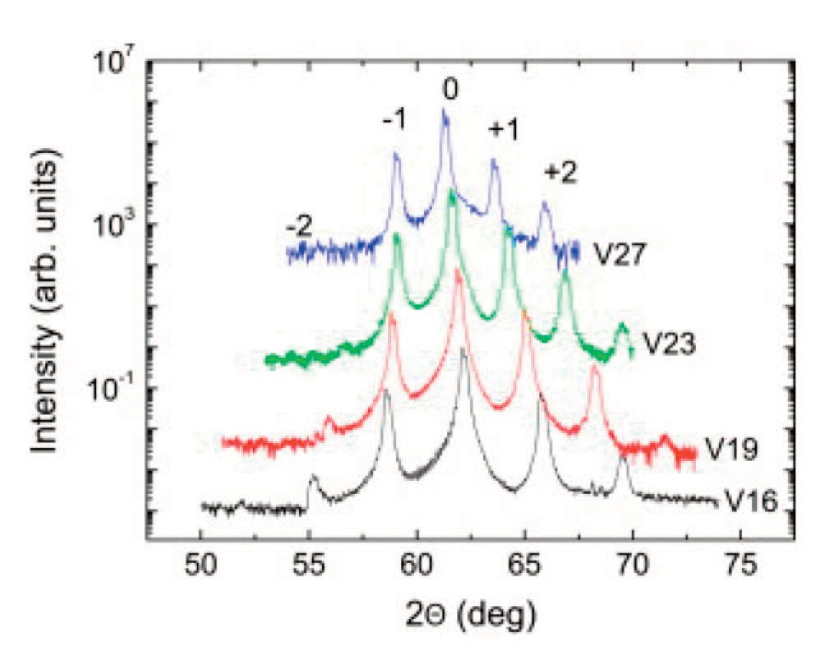If using visual representations of results, including charts or graphs, these are labelled as Figures (Fig.1, Fig.2, and so on); Tables are text and data presented in columns and rows. Both Figures and Tables should be numbered and labelled with text, as below.

In Fig. 1 the XRD patterns are presented for four representative samples. The (002) peak, labelled as …

Figure 1. Measured X-ray diffraction of four representative samples.

The figure caption should be placed below the figure as figures are normally read from the bottom up.

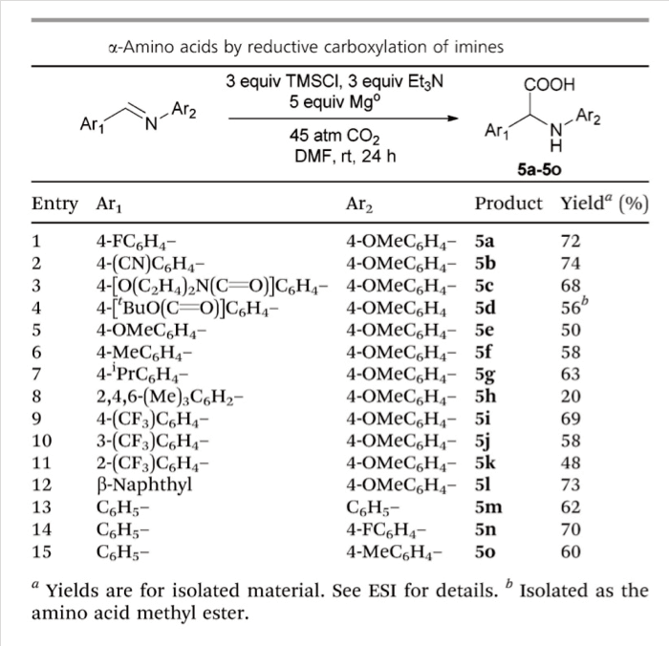If the material that is being used in the text is being reproduced from another source, it must be referenced accordingly, with the citation appearing in the reference list at the end of the assignment, as in the following example:

Table 2, reproduced below, summarizes the results of a survey of substrate scope which was conducted once the reaction conditions had been optimized2........

Table 2: α-Amino acids by reductive carboxylation of imines2

Reference at the end of the assignment:

2. A. A. Sathe, D.R. Hartline and A.T. Radosevich, Chem Commun., 2013, 49, 5041.

The table caption should be placed above the table as tables are normally read from the top down.

A list of figures, tables etc. should be include after the reference list to indicate what has been included within the text:

Reference list:
1...............
2. A.A. Sathe, D.R. Hartline and A.T. Radosevich, Chem Commun., 2013, 49, 5041. 3 ...............

List of Figures:
Figure 1. Measured X-ray diffraction of four representative samples Figure 2. A polarity inversion route to α-Amino acids

List of Tables:
Table 1. Conditions for reductive carboxylation
Table 2. α-Amino acids by reductive carboxylation of imines

This document is available in Welsh. Mae’r ddogfen hon ar gael yn Gymraeg.
End of Guide

