Guide to using

FINDit
Library Services
Summer, 2018

Contents
1 What is FINDit? 1
2 Performing basic searches 1
2.1 How can I do more with the search panel? 2
2.1.1 Searching for a phrase 2
2.1.2 Searching for any specified words or phrases 3
2.1.3 Excluding words or phrases 3
2.1.4 Searching using wildcard characters 4
2.1.5 Grouping terms within a query 4
2.1.6 Selecting your search scope 5
2.1.7 Using the Articles search scope 6
3 Performing advanced searches 7
4 Using Browse 8
5 Your space in FINDit 9
5.2 Why should I sign out? 10
5.3 My Account 10
5.3.1 Personal settings 10
6 Using My Favourites 11
6.1 Saving and managing records 11
6.1.1 Saving a record 11
6.1.2 Removing a record 12
6.1.3 Labelling a record 12
6.1.4 Removing a label 13
6.1.5 Viewing grouped records 14
6.1.6 Viewing a saved record 15
6.1.7 Sorting the list of saved records 16
6.2 Saving and managing searches 17
6.2.1 Saving a query from the results list 17
6.2.2 Saving a query from My Favourites 18
6.2.3 Deleting a saved query 18
6.2.4 Deleting a group of saved queries 19
6.3 Saving and managing alerts 19
6.3.1 Setting an alert 20
6.3.2 Clearing an alert 21
6.4 Creating an RSS feed 21
7 Using the brief results 22
7.1 Personalizing the results 23
7.1.1 Setting the personalized results preferences 24
7.2 Filtering the results 26
7.2.1 Including and excluding multiple facets 26
7.2.2 Adding persistent facets 27
8 Journal Search 28
9 Using the full display 29
10 Index 32

1 What is FINDit?

FINDit is the University of South Wales library search service.

It provides simple, one-stop searching for books, e-books, articles, DVDs and much more. It allows all students and staff to manage their library account online and offers a range of personalized features to save favourite items or search queries.

This new version, available from Summer 2018, has a range of improvements, including:

- better interface for mobile devices
- full item details on a single page
- links to related publications
- 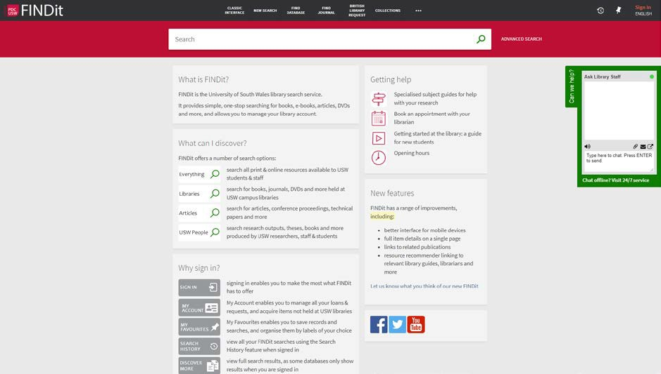resource recommender linking to relevant library guides, librarians and more

Figure 1. FINDit new interface

2 Performing basic searches

You can search very easily in FINDit. Just type one or more words that you are looking for and click the Search button. If you enter multiple words, FINDit will return results that contain all of the specified terms.

Once you are familiar with the basic FINDit search, you might want to try doing more with the Search panel or use the Advanced Search option. Both of these options offer numerous features for making your searches more precise and enable you to get results that are more useful.
Note
You may search for titles using ISBNs and ISSNs with or without hyphens. If you are not getting expected results with hyphens, please try your search again without hyphens.

2.1 How can I do more with the search panel?

You can do more than just a simple search with the Search panel by placing the following operators between words or phrases: AND, OR, and NOT. Searches with multiple operators are processed in the following order, from left to right:

- ( ) – parentheses allow you to group search terms and alter the order of precedence.
- AND and NOT – left-to-right precedence is used in case of multiple operators.
- OR – left-to-right precedence is used in case of multiple operators.

Although operators provide greater control over the search, the full search string is no longer treated as a phrase and search enhancements (such as inflection of a phrase based on correlation statistics) will not be applied to the query. For example, the following queries are treated differently even though they appear to be identical:

- honey bee communication – FINDit treats the entire query as a phrase and returns results in which all of the words may be closer together.
- honey bee AND communication – FINDit treats honey bee and communication as separate phrases and returns results in which both phrases may not be as close together.
Note

FINDit assumes that you are searching for all of the words unless you type OR or NOT between words and phrases.
For right-to-left languages (such as Hebrew), the precedence is right-to-left. Searches are not case-sensitive.

2.1.1 Searching for a phrase

To search for an exact phrase, type quotation marks around the phrase. You can combine both words and phrases in your search.
Note

If you do not enclose the phrase with quotation marks, the system will find items that contain the individual words in the phrase, regardless of whether these words are located next to each other in the order specified.

If a comma is used to separate words in a list, the comma must be followed by a space. Otherwise, the system will consider the comma to be part of the word and return fewer results than expected.

For example, to search for global warming as one term, type the following in the search box:

Figure 2. A simple phrase search.

2.1.2 Searching for any specified words or phrases

You can search for items that contain at least one of the words or phrases you type in the Search box. To do so, type OR between the words or phrases.
Note

If you search for words or phrases without specifying OR or NOT, FINDit assumes that you are searching for all the specified words or phrases.

For example, to search for items with the word Welsh or the word Celtic, type the following in the search box:

Figure 3. Searching for any specified words using the OR operator
Note

To use Boolean operators (AND, OR, NOT) within search phrases, you must enter them in uppercase letters. Otherwise, FINDit removes them and performs a simple search that includes all search phrases.

2.1.3 Excluding words or phrases
You can exclude items that contain specific words or phrases. To do so, type NOT and then type the word or phrase to exclude.
Note

If you search for words or phrases without specifying OR or NOT, FINDit assumes that you are searching for all of the specified words or phrases.

For example, to search for items with the word Celtic and exclude any of these items with the word Welsh, type the following in the search box:

Figure 4. Excluding specified words using the NOT operator
Note

If parentheses are not used for a query that contains multiple operators, it is recommended that you use the NOT operator last to ensure that results are excluded from the entire query. For example: cycling AND safety NOT helmet. If it is necessary to place the NOT operator elsewhere, make sure that you enclose the operation with parentheses. For example: (cycling NOT safety) OR helmet.

2.1.4 Searching using wildcard characters

You can include the following wildcard characters in your searches:
- ? – enter a question mark to perform a single character wildcard search. For example, type wom?n to search for records that contain the strings woman, women, and so forth.
- – enter an asterisk to perform a multiple character wildcard search. For example, type cultur* to search for records that contain strings, such as culture, cultural, and culturally.
Note

The system ignores wild card characters placed at the beginning of search terms. For example, the system treats the search terms ?aying and *aying as if you had searched foraying.

2.1.5 Grouping terms within a query

You can use parentheses to group terms to clarify the order of multiple operators specified in a query.

Example 1: The following query searches for records that contain Shakespeare and either tragedy or
sonnet:

Figure 5. Using parentheses to group search statements together

When using more than one operator, it is strongly recommended to use parentheses to clarify precedence. For example, if no parentheses are specified in the above query, FINDit will apply the precedence rules and instead group the words Shakespeare and tragedy as follows:

Figure 6. Precedence rules
Note
After the results are returned, FINDit will display the altered query in the search box so that you can decide whether to modify and re-execute your query to get expected results.

Example 2: The following query searches for records that contain either Irish or Celtic and do not contain
Gaelic:

Figure 7. Precedence rules

If no parentheses are specified in the above query, FINDit will apply the precedence rules and instead group the words.

Celtic and Gaelic as follows:

Figure 8. Precedence rules

2.1.6 Selecting your search scope

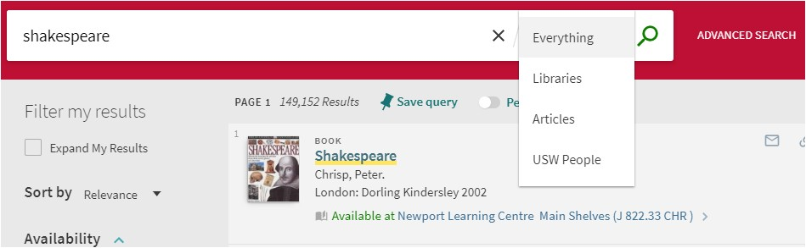The search scope defines where the system should perform the search. A default search scope is predefined based on your login, usually corresponding to your major field of study or some other criteria set up by the institution. However, you can change the scope of your search by selecting a search scope from the drop- down list as shown in the following example.

Figure 9. Selecting a search scope

2.1.7 Using the Articles search scope

Articles is a centralized search index that encompasses tens of millions of records of global or regional significance that are harvested from primary and secondary publishers and aggregators. To search from these resources, select the Articles search scope or a search scope that includes it.

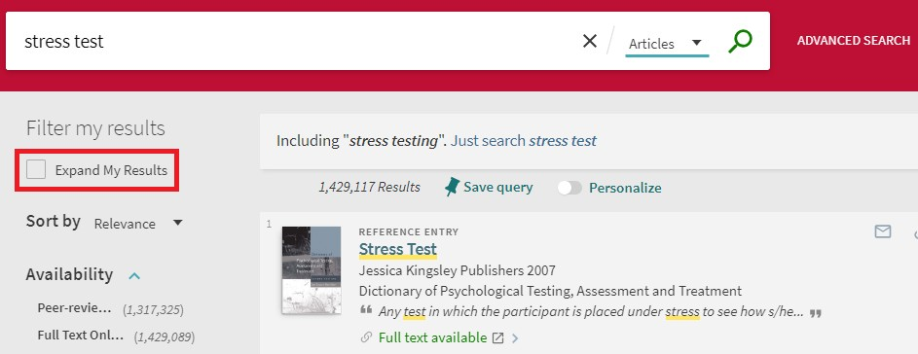If you want to receive results for Articles items that do not contain full text, select the Expand My Results check box.

Figure 10. Expanding results to including items where no full-text is available

2.2 Search limits

The system will display a message and provide suggestions when the following limits are exceeded:

- The query contains more than 30 Boolean operators.
- The query contains more than 8 question marks.
- The query contains more than 8 asterisks and the word length is greater than 2 (such as abb* or ab*c).
- The query contains more than 4 asterisks and the word length is less than 3 (such as ab*).
- The entire query consists of a single letter and an asterisk (such as a*).

3 Performing advanced searches

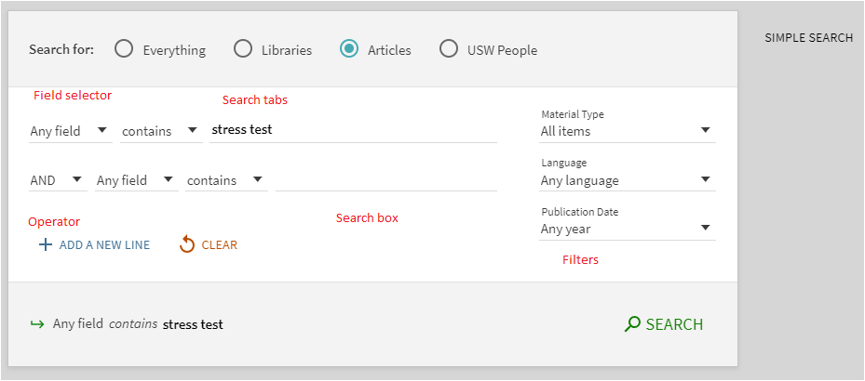The Advanced Search page allows you to specify additional lines of criteria, which are not available with the Basic Search. In addition, it allows you to specify filters prior to executing the query.

Figure 11. Advanced search features

The Advanced Search page contains the following components and options:

- Search for – if provided, search tabs allow you to search within a specific category of materials (such as materials that belong to your institution, course reserves, or any additional repositories that are supported by the library. Whether search tabs are provided or not, you can also limit your search results by specifying search scopes and filters.
- Search Scope – search scopes allow you to narrow search results further by specifying subcategories that may further limit the scope of searches to a campus, library, or additional search indexes.
- Add a New Line – advanced searches allow you to include a maximum of seven search criteria lines, which contain the following parameters: operator, field selector, search type, and search box.
- Field selector – for each search line, this parameter allows you to narrow the search to all search fields or a particular field (such as title and subject).
- Search type – for each search line, this parameter indicates whether the phrases in your query are treated as phrases or exact phrases. The following values are valid:
  - is (exact) – returns results that contain phrases that exactly match the phrases specified in the query.
  - contains – returns results that contain all words in the phrase, but the words may be in a different order and may not be as close together.
  - starts with – returns results that contain words that start with the specified string.
•
Note

If your query includes operators that separate phrases in which one or both of the phrases contain multiple words, FINDit will use parentheses to group the words in each multiple-word phrase. For example, FINDit will convert the query Donald Duck OR Disney to (Donald Duck) OR Disney to distinguish it from the following query: Donald (Duck OR Disney).

Note

Because left-anchored searches are permitted with title searches only, the Field Selector parameter will display Title when starts with is selected.

- Operators – as with basic searches, you can include the following operators between words and phrases in each search line: AND, OR, and NOT. In addition, the Operator drop-down list allows you to select the operation that is used between search lines.
- Search box – for each search line, enter the search query text, which may include words, phrases, and operators (AND, OR, and NOT).
- Filters – filters allow you to narrow your results to specific metadata (such as a material type or date range). In the search results, you can include and exclude facets to filter your results further.

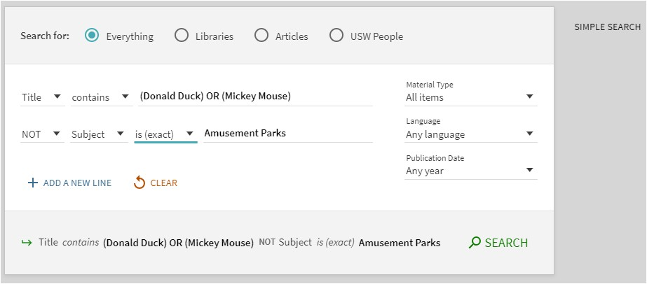In the following example, matching records must contain either the words Donald and Duck or the words Mickey and Mouse in the title, and the subject of the records must not have the exact phrase Amusement Parks. From the matching records, only the English articles are displayed in the results.

Figure 12. Advanced search example using Operators

4 Using Browse
The Browse search allows you to browse library material (local material only) in order to find information of relevance quickly. You can browse material by author, title, and subject. In the results, you can click an underlined entry to see its associated records. It is also possible to browse by call number, which returns a list of associated records in brief format. Clicking a title displays its full record.

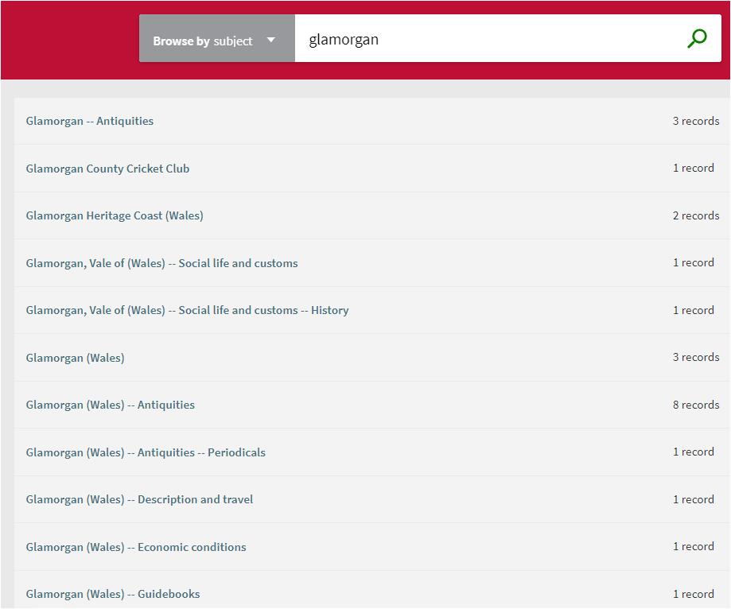Figure 13. Example of Browse search results

5 Your space in FINDit

This section contains topics associated with your personal space and settings in FINDit.

5.1 Why should I sign in?

When you sign in to FINDit, you are able to do the following:

- Set preferences for your current and future sessions. You can set your preferences so that they reflect the way you usually search, and save them for future sessions.
- Add items you found permanently to your Favourites. You can save items for future use.
- Access external licensed resources. The institution offers licensed information resources to its users. Once you sign in, you can search and retrieve items from these additional resources.
- Use library services. You can benefit from library services such as requesting or recalling items.

5.2 Why should I sign out?

You should sign out of FINDit so that your searches remain private and your personal settings and Favourites are not tampered with by anyone else.

5.3 My Account

My Account enables you to view the contents of your account and perform library services, such as renewing a book or cancelling a request. In addition, it lets you define your personal FINDit settings. To access My Account, place your cursor over the Sign in area at the top of any page to display the My Account link.
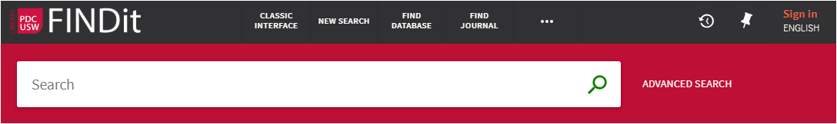

Figure 14. Sign in to access My Account features

5.3.1 Personal settings

You can tailor the FINDit user interface so that it reflects the way you usually search. For example, you can specify the default language, the maximumnumbers of searchresults per page, your default e-mail address, and your cellphone number. To set your preferences, click the Personal Details tab on the My Account page.
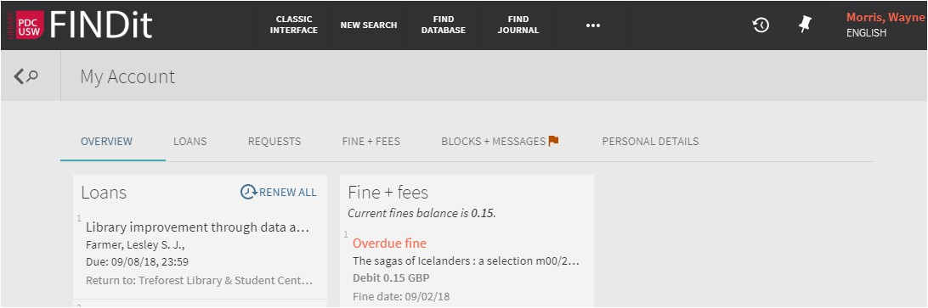

Figure 15. Personal details are available
Note
To keep your settings for future sessions, you must sign in and save your preferences.

6 Using My Favourites

The My Favourites page, which is accessed by clicking the My Favourites pin button at the top of each page, contains the following tabs:

- Saved Records – This tab displays all of your saved records and allows you to manage your saved records.
- Saved Searches – This tab displays all of your saved searches and allows you to manage your saved searches. In addition, it lets you set up alerts and RSS feeds, which let you know when results have changed for saved searches.
- Search History – This tab displays all of your searches for the current session and allows you to manage your current session's searches.

6.1 Saving and managing records

FINDit allows signed-in users to save found records for subsequent sessions. After a record has been saved, the My Favourites > Saved Records page allows users to perform the following operations on saved records: view, delete, and label. Labels allow you to group and manage similar records.
Note
For guest users, records are saved in local memory and are not retained between browser sessions.

6.1.1 Saving a record

To save a record:

- Perform a search.
- Click the pin button next to the item that you want to save in the search results.

The system highlights the item changes the icon to the pinned icon, and adds the item to the My Favourites page.

Note
You must Sign in to save items for future sessions.

6.1.2 Removing a record

To remove a record from My Favourites:

- You can click the Unpin button next to the item either in the search results or on the My Favourites > Saved Records tab.

Figure 16. Remove from search results

Figure 17. Remove from saved records tab

6.1.3 Labelling a record
Labels allow you to group records in private lists so that you can access these records as needed in the future. You may assign multiple labels to a saved record if you want to include that record in multiple lists.

To add a record to a private list:

- Click the My Favourites pin button that appears at the top of each page.
- Select the Saved Records tab (if not selected already).
- Click the Add Label pencil button.

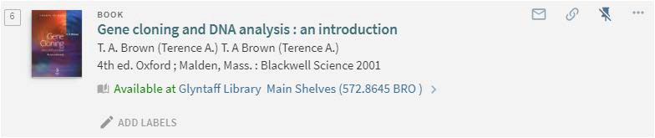

Figure 18. Add a label of your choosing

- Enter the name of the Label

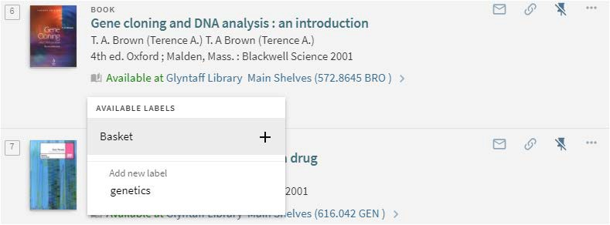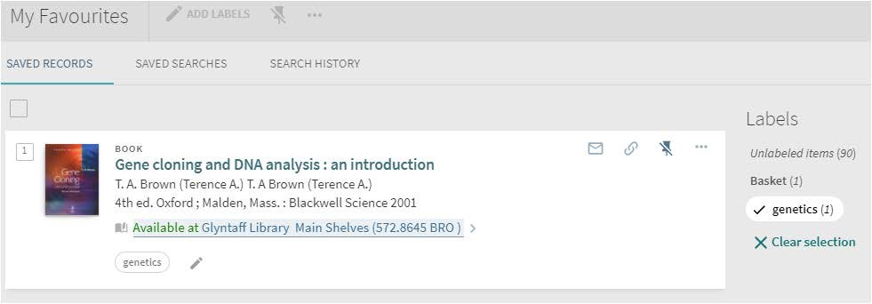Figure 19. Enter the name of the Label of your choosing

Figure 20. Example of a Label

6.1.4 Removing a label

To remove a label:

- Click the My Favourites pin button that appears at the top of each page.
- Select the Saved Records tab.
- Click the record's Add Label pencil button
- Click the Delete Label cross button to remove the label.

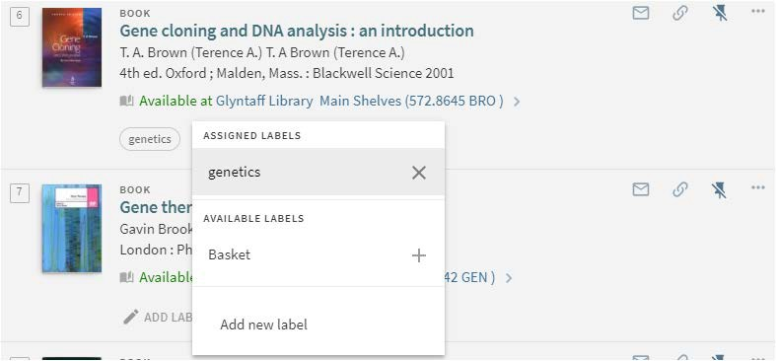Figure 21. Deleting a Label

6.1.5 Viewing grouped records

To view grouped records:

- Click the My Favourites pin button that appears at the top of each page.
- Select the Saved Records tab.
- 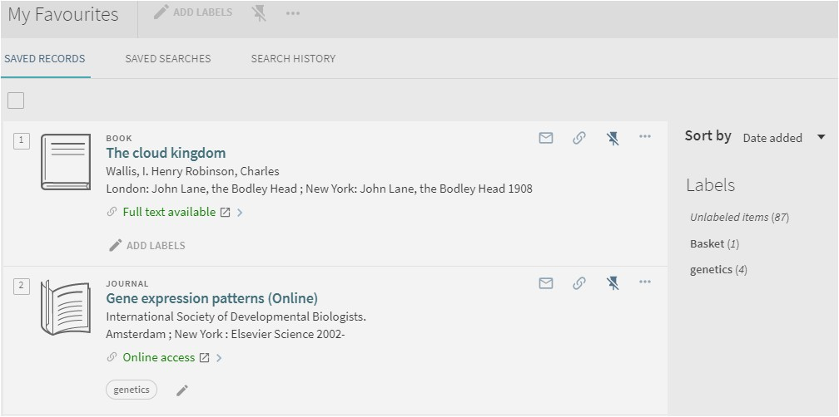In the Labels section, click the label's link to view the records that have been assigned that label.

Figure 22. Selecting the Label link

The following example shows the selected label and the list of items that have been assigned that label.

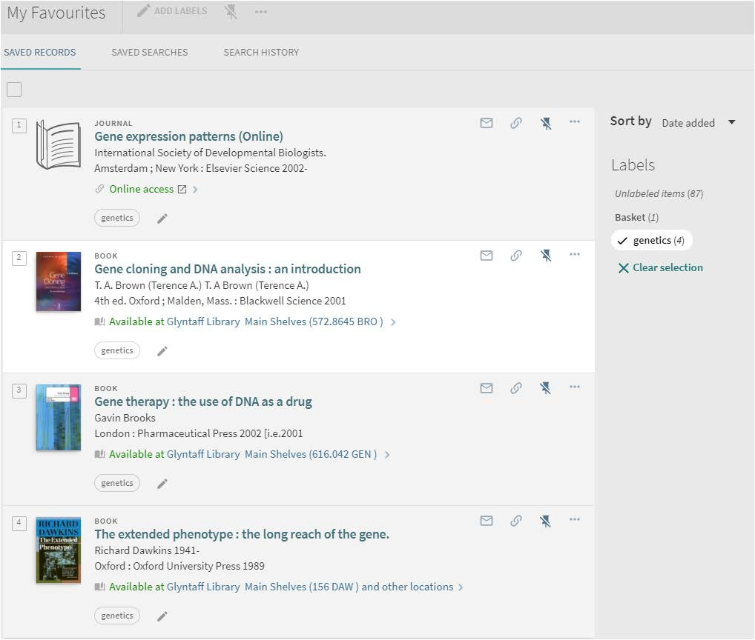Figure 23. Example grouping of saved records

6.1.6 Viewing a saved record
To view a saved record:

- Click the My Favourites pin button that appears at the top of each page.
- Select the Saved Records tab (if not selected already).
- In the list of saved records, click the record that you want to display.

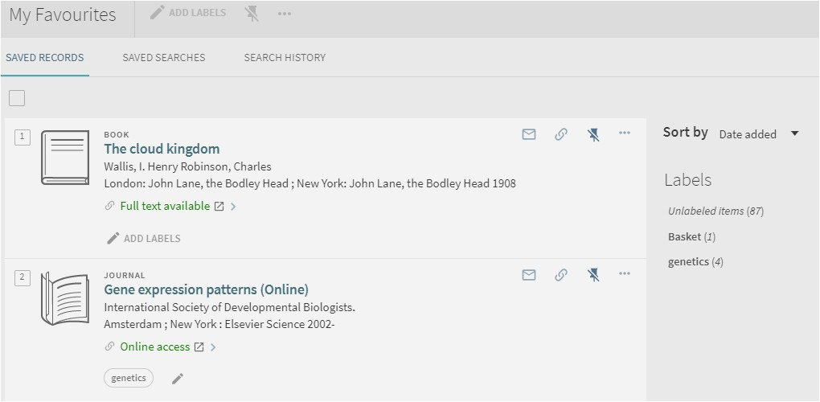Figure 24. Saved records tab

6.1.7 Sorting the list of saved records
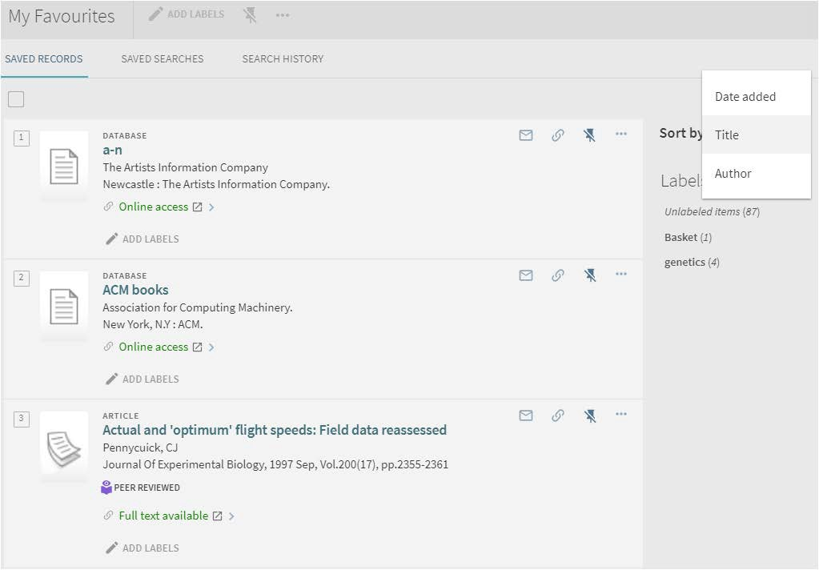The following Sort by options allow users to sort their list of saved records to locate specific records: Title, Author, and Date added.

Figure 25. Sorting saved records by date, title or author

6.2 Saving and managing searches

FINDit allows signed-in users to save searches between sessions and receive email alerts when there is an update to the saved search query. After a query has been saved, the My Favourites > Saved Searches page allows users to perform the following operations on saved searches: view, delete, create an RSS feed, and set/clear an alert.
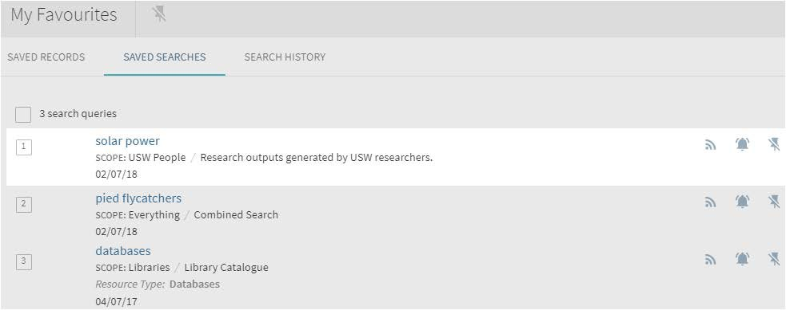

Figure 26. Saved searches in My Favourites

6.2.1 Saving a query from the results list
To save a query from the results list:

- Perform a search that you want to save.
- 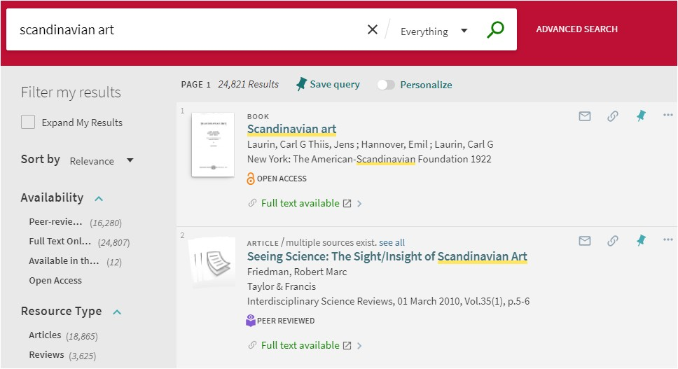Click Save Query, which appears above the search results.

Figure 27. Save a search query

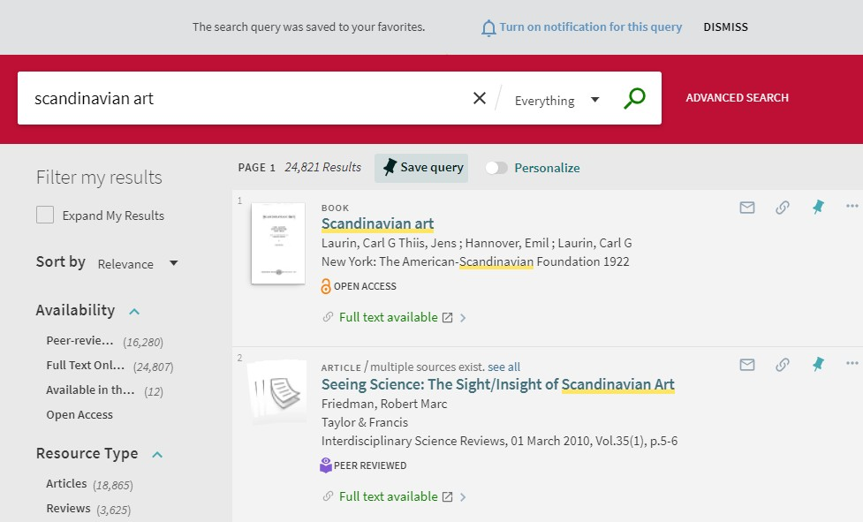In addition, you will have an opportunity to set an alert for this query by clicking the notification link that appears above the search box.

Figure 28. Set alert notification for future results matching your search

6.2.2 Saving a query from My Favourites
To save a query from the Search History tab:

- Click the My Favourites button at the top of the page.
- Select the Search History tab to display your current session's search history.
- Click the pin button that appears next to the query that you want to save. The record should now appear under the Saved Searches tab as well.

6.2.3 Deleting a saved query

To delete a query:

- Click the My Favourites pin button at the top of the page.
- Select the Saved Searches tab to display all of your saved searches.
- Click the Unpin button that appears next to the query that you want to remove from the list.

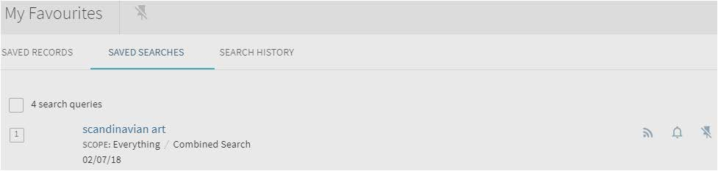Figure 29. Deleting a saved search

6.2.4 Deleting a group of saved queries
To delete a group of queries:

Click the My Favourites pin button at the top of the page.
Select the Saved Searches tab to display all of your saved searches.
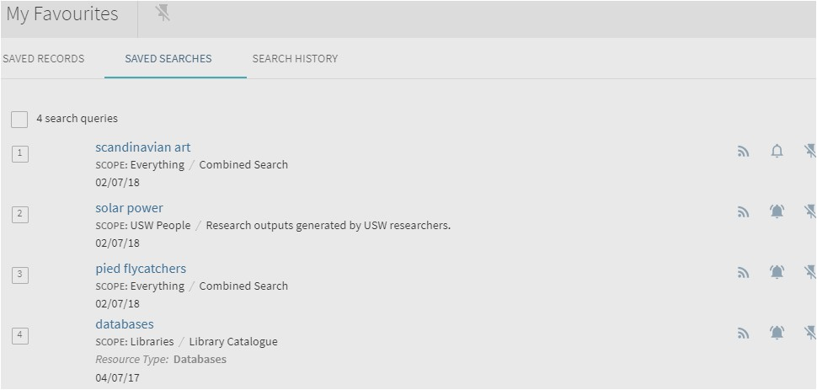Select the check boxes of the queries that you want to delete.

Figure 30. Select multiple saved searches to remove
Note

To select all queries, click the check box above the list.

- Click the Unpin button hat appears above the list.

6.3 Saving and managing alerts

FINDit allows signed-in users to receive email alerts when there is an update to the saved search query. After an alert has been set, the My Favourites > Saved Searches page allows users to perform the following operations on alerts: set/clear an alert and update email addresses.

6.3.1 Setting an alert
To set an alert:

- Click the My Favourites pin button at the top of the page.
- Select the Saved Searches tab to display all of your saved searches.
- 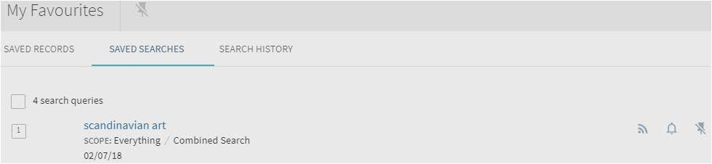Click the Set Alert bell button that appears next to the query to set the alert.

Figure 31. Set alert button

If necessary, update the email address to which the alert is sent. If the alert had not been previously set, the address defaults to the value stored in the user's personals ettings.

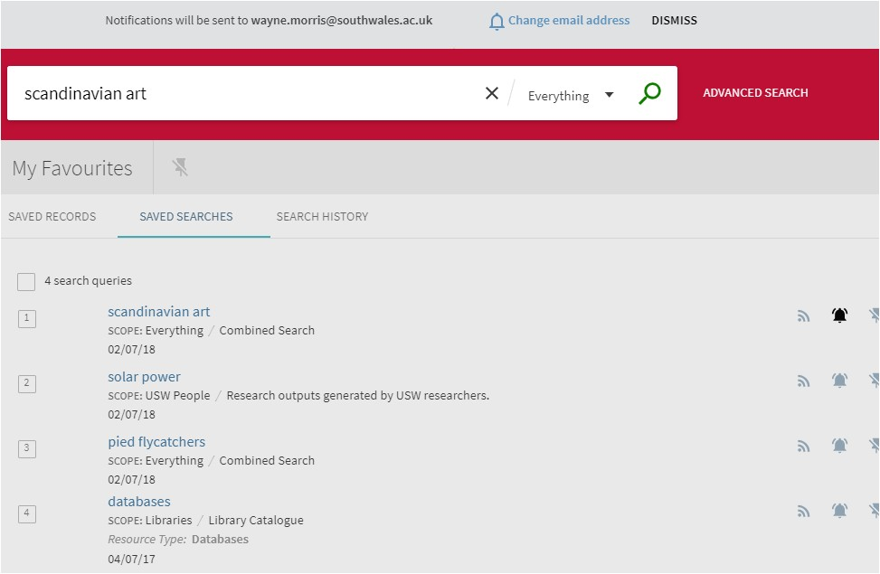Click the Change email address link above the search box.

Figure 32. Change email address for alerts

Modify the email address and then click SAVE.

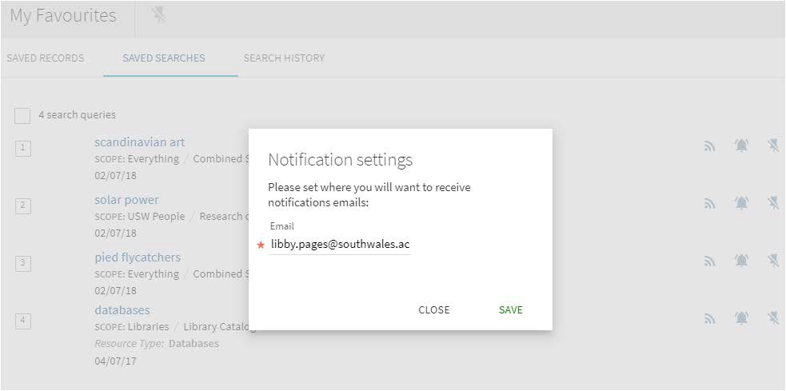Figure 33. Modifying email address for notifications

6.3.2 Clearing an alert

To clear an alert:

- Click the My Favourites button at the top of the page.
- Select the Saved Searches tab to display all of your saved searches.
- Click the Clear Alert bell button that appears next to the query to clear the alert.

Figure 34. Clear alert button

6.4 Creating an RSS feed

The Rich Site Summary(RSS) functionality allows FINDit users to be informed of changes to results in their saved searches.

To enable RSS for a saved search:

- Open the My Favourites page by clicking the My Favourites pin button on the top menu of any page.
- On the My Favourites page, click the Saved Searches tab.

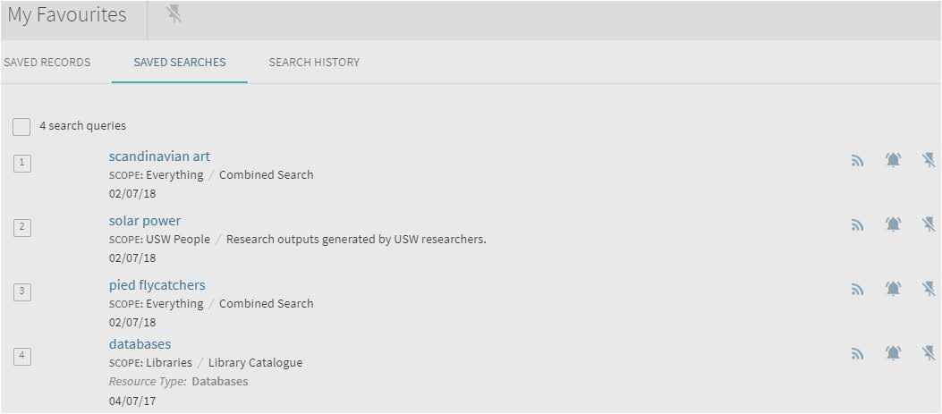Figure 35. Selecting an RSS feed for your Saved Searches

- Click the RSS button for the saved search that you want to monitor.
- Subscribe to the feed if your browser has an RSS reader.

7 Using the brief results

The Brief Results page display all the items that match your search query. For each item, the following information displays:

- Resource Type – the format of the item, such as book, article, journal, and so forth.
- Title – click the title to display more information and services for the item.
- Author, creator, and date – the item's author, creator, and publication date
- Availability status – click this link to display more information and services (such as requesting or viewing the item).
- Send to actions – the Send To actions allow you to perform actions on the item (such as e-mailing the item, creating a citation for the item, and so forth).
- Facets – the facets on the left-side of the page allow you to filter your results by categories (such resource type and date) and to specify a type of sort.

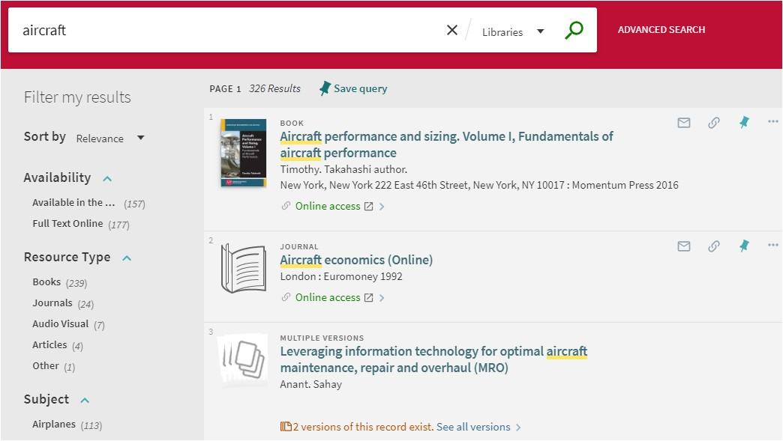Figure 36. Brief results display

7.1 Personalizing the results

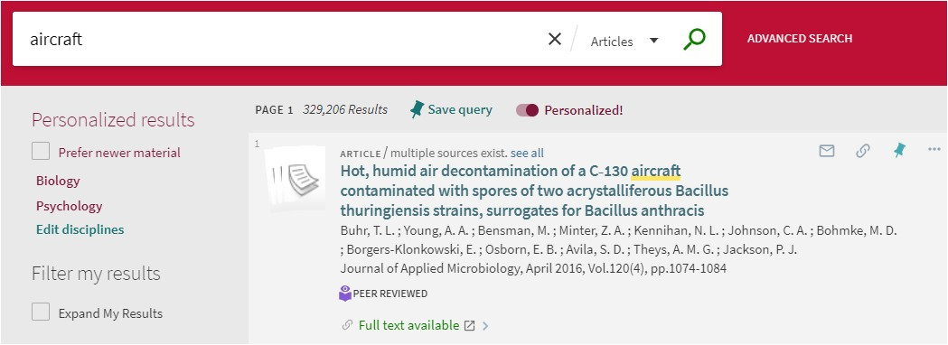Personalized settings allow users to boost the rankings of electronic records that match their preferred disciplines.

Figure 37. Personalized Results enabled

The Personalized results section lists the active preferences and allows users to remove selected disciplines, edit selected disciplines, and give preference to newer material.

7.1.1 Setting the personalized results preferences

The Personalize the Results dialog box allows users to set their discipline preferences, which are retained during the session for guests and unsigned users and between sessions for signed-in users.

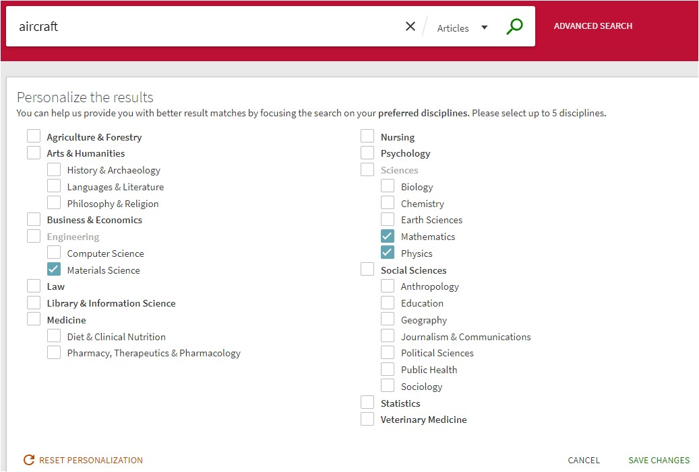Figure 38. Personalize the results options

To enable personalized settings:

- 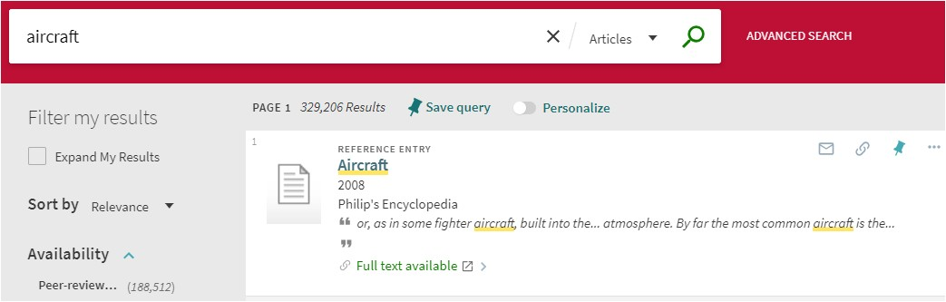Perform a search within a search scope that includes Articles records.

Figure 39. Enabling Personalized results

- Click the Personalize button that appears above the list of results.
- In the Personalize the results dialog box, select up to five disciplines.
- Click PERSONALIZE IT.

To edit personalized settings in the new UI:

- Perform a search within a search scope that includes Articles records to display the Personalized results section.

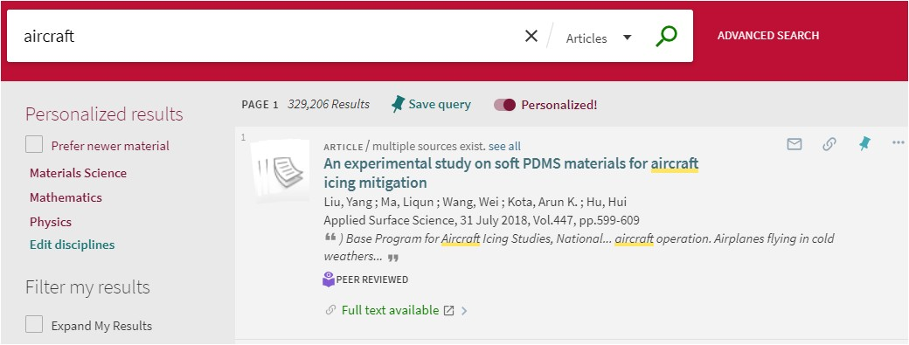Figure 40. Personalized results section

- If you want to give preference to newer records, select the Prefer new material check box.
- Click Edit in the Personalize the results section to open the Personalize the results dialog box.

Figure 41. Personalize the results dialog box

- In the Personalize the results dialog box, select up to five disciplines.
- Click SAVE CHANGES.

7.2 Filtering the results

The Tweak my results section, which may appear on either the right or left side of the Brief Results page, contains a list of categories, which are referred to as facets. By including and excluding these facets (such as date, author, record type, and so forth), you can narrow the search results to get the results you are seeking.

7.2.1 Including and excluding multiple facets

When facets are added one at a time, the system returns the remaining results that match the selected facet value. You can specify more complex filtering if you select multiple facets and then apply them to the results at the same time. For example, if you select Subject facet values Agriculture and Botany and Resource Type facet values Book and Other, the system returns results that include all records that match the following criteria:

- The records must contain either Agriculture or Botany subjects.
- And the records must be either Book or Other resource types.

If you had selected these facet values separately, the resulting records would have to contain all of these facet values.

To include/exclude multiple facets at a time:

- 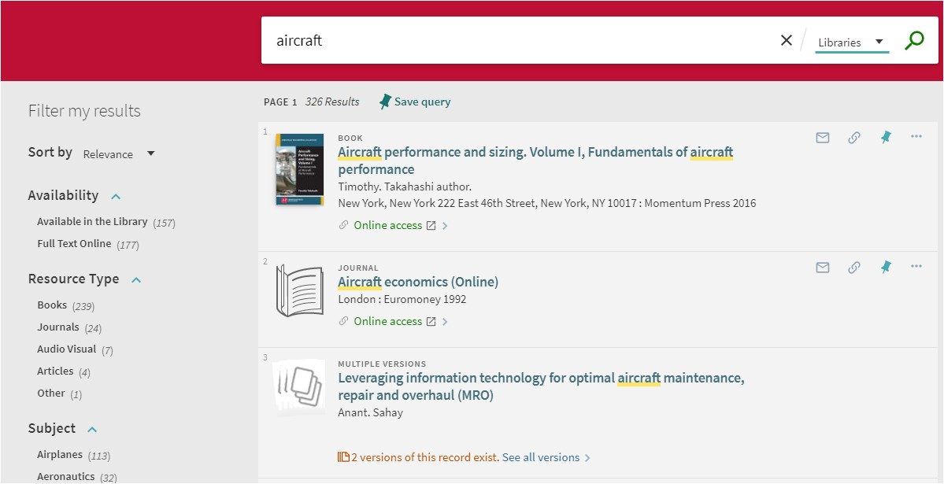Perform a search.

Figure 42. Filter my results on the Brief Results page

- For each facet that you want to include and exclude, hover over the facet in the Filter my results section and then perform one of the following actions:
  - Include facet – select the check box on the left side of the facet. If you want to include a facet that has already been marked for exclusion, click the tick button on the right side of the facet.
  - Exclude facet – if you have already included a facet, click the untick button on the right side of the facet to mark it for exclusion. If you have not already marked a facet for exclusion or inclusion, you must first select the facet's check box and the click the untick button on the right side of the facet. Otherwise, a single facet will be excluded immediately.
- Click Apply Filters to filter your results. The selected facets will appear in the Active filters section.
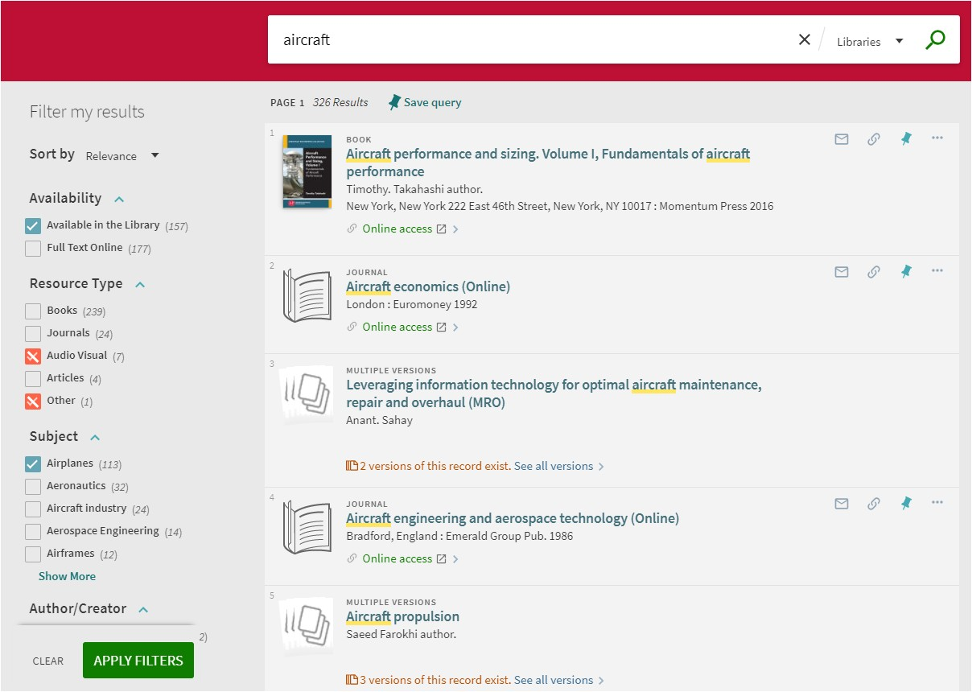

Figure 43. Applying filters to modify search results

7.2.2 Adding persistent facets

When performing many similar types of searches, you may want to retain your filters for subsequent searches within a session.

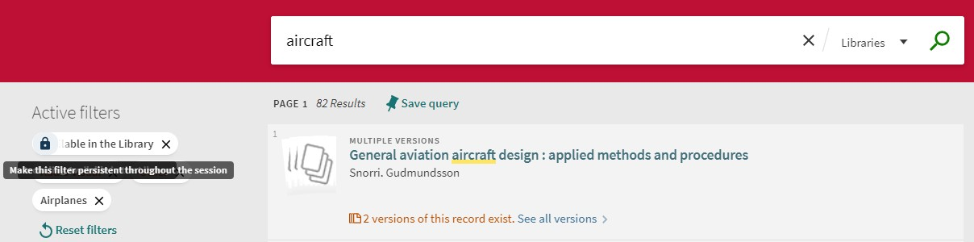To make a facet persistent, hover the cursor over the facet in the Active filters section and then click the facet's padlock.

Figure 44. Active sticky facet

To remove a facet's persistence, click the facet's padlock or delete the facet.

8 Journal Search

Journal Search, which is also known as the A-Z List in the classic interface, allows users to search for journals by title or ISSN or to browse for journals that start with either any number (0-9), a specific letter (A-Z), or all other non-Latin characters (OTHERS).

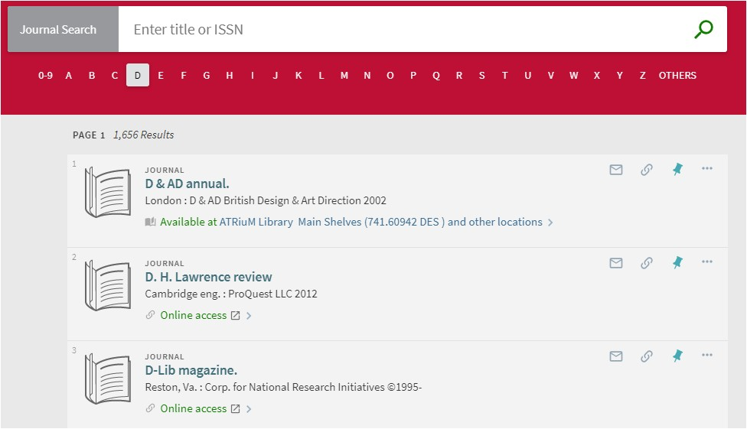The number of results per page is 20 (not configurable), and each result contains the following information: resource type, thumbnail, title, publisher, date, availability, and actions (such as Citation and E-mail).

Figure 45. Journal Search results

9 Using the full display

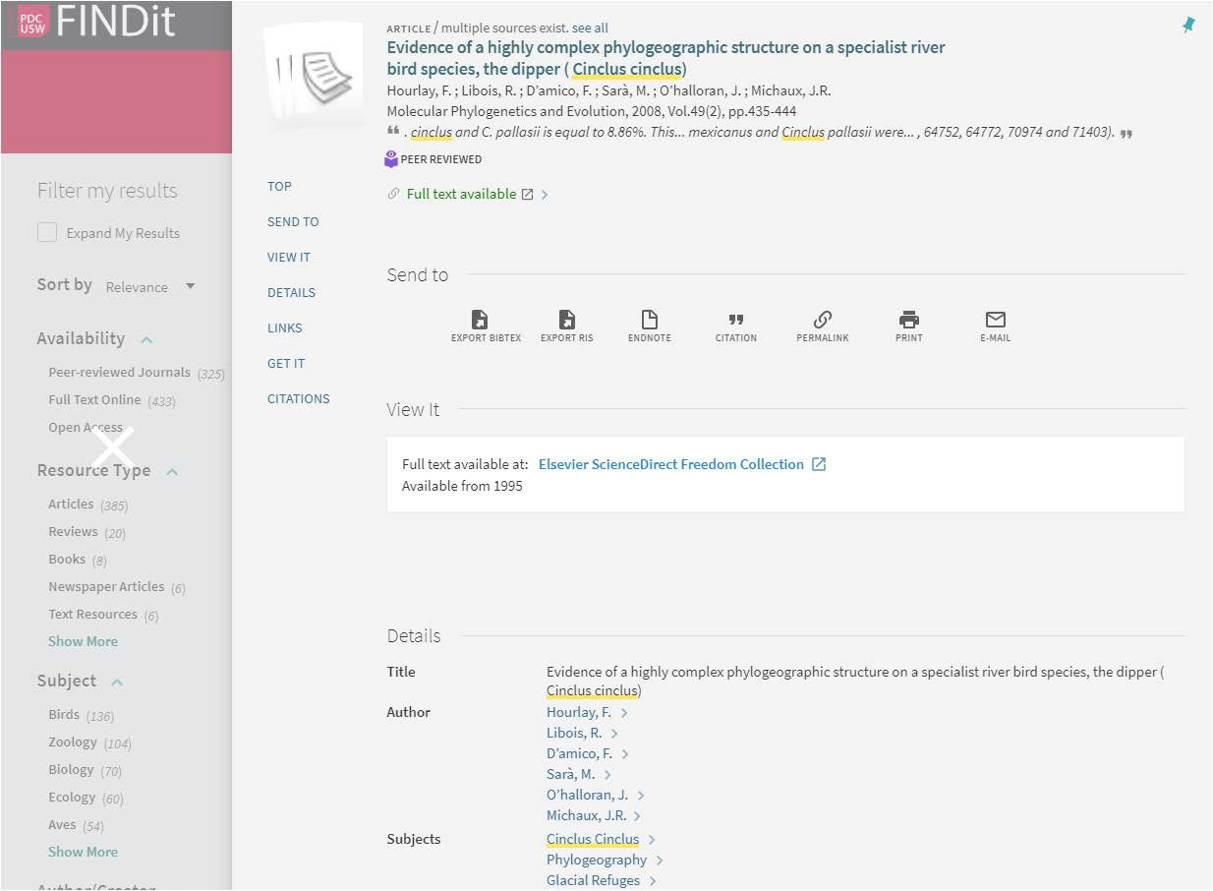After selecting an item in the Brief Results, the record's Full Display opens to display additional information. Users can either scroll to a particular section or use the links shown on the left side of the page.

Figure 46. Full display, highlighting Menu, Sent to and View it sections

The item's information is organized by the following sections:

- Send to – this section allows users to perform the following actions on the selected item: email item details, create a citation, print, send to reference management service (such as EndNote), and create a permalink.
- View online – this section appears only if the item is available for online viewing.
- Get it – This section allows you to request physical items (such as books and audio CDs) from your institution. Depending on your institution, you may be able to request these items directly from FINDit. Otherwise, this section will link to your institution to perform requests.

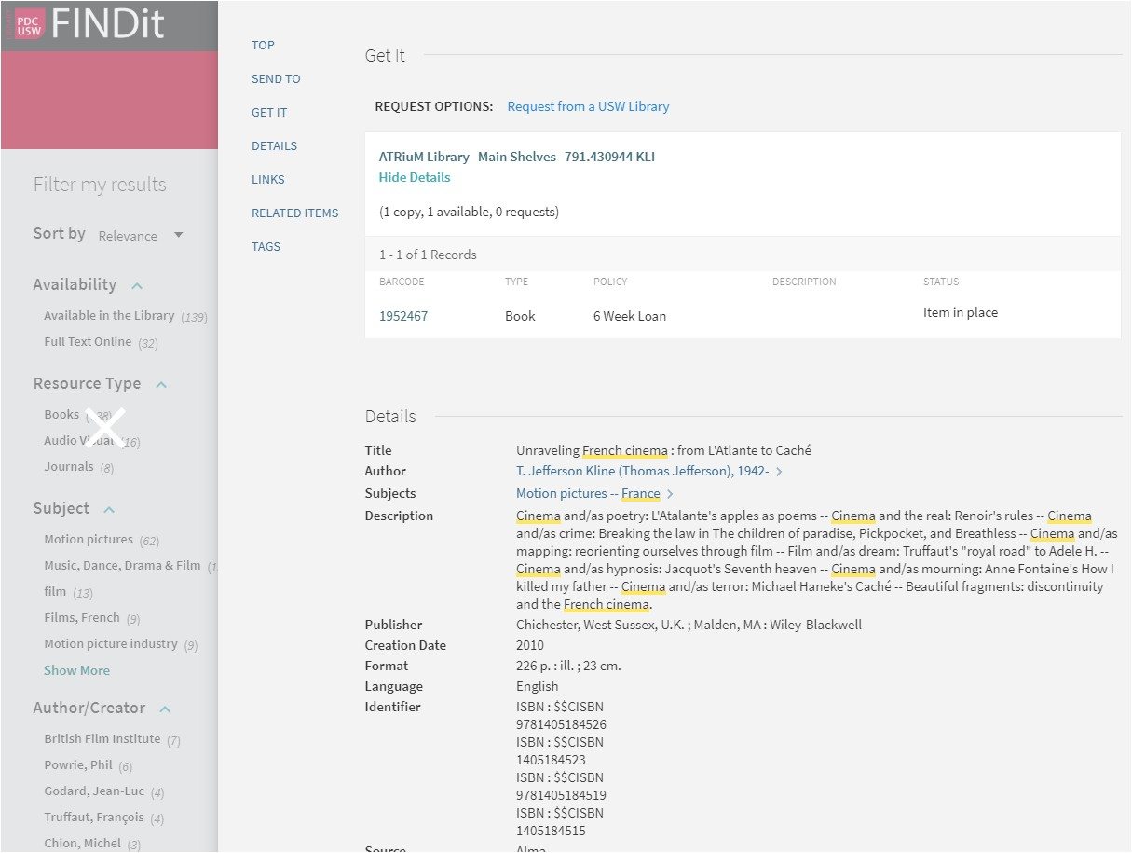

Figure 47. Full display, highlighting Get it and Details sections
Note

You may have to sign in to FINDit or your institution to make a request.

- Details – displays additional details (such as the publisher and creation date) to help the user decide whether to choose this item.
- Related items – displays items that are about the same topic. This feature only displays when searching the Libraries scope.

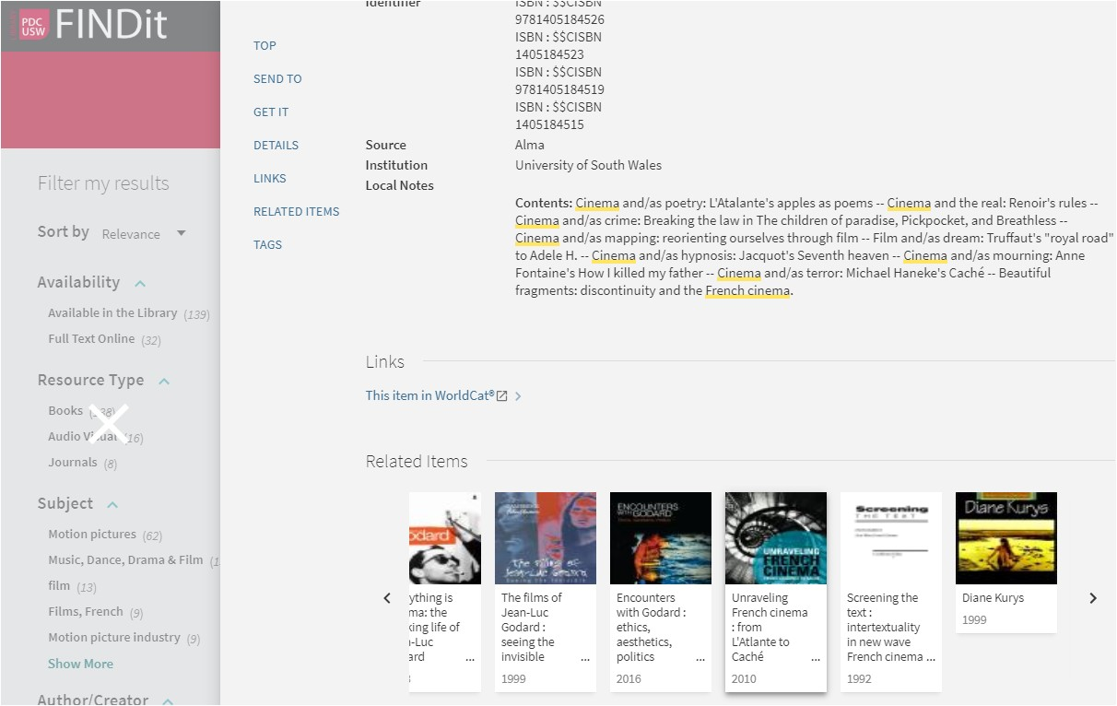

Figure 48. Related items section

10 Index

Add Label, 12, 13
Advanced Search, 1, 6
alerts, ii, 11, 17, 19, 20
AND, 2, 3, 7
Articles, i, 5, 24
asterisks, 6
author, 8, 16, 22, 26
Availability, 22
Boolean, 3, 6
Brief Results, 22, 26, 28
Browse, i, 7, 8
call number, 8
classic interface, 28
combine, 2
comma, 2
Details, 10, 30
EndNote, 29
exclude, 3, 7, 26 Expand My Results, 5 facets, ii, 7, 22, 26, 27 Filter my results, 26 filters, 6, 7, 27
Full Display, 28
Get it, 29, 30
grouped records, i, 14 guest, 11
Journal Search, ii, 28 Labels, 11, 12, 14
Libraries scope, 30
mobile devices, 1 My Account, i, 10
My Favourites, i, ii, 10, 11, 12, 13, 14, 15, 17, 18, 19,
20, 21
NOT, 2, 3, 7

notification, 18
operators, 2, 3, 4, 6, 7
OR, 2, 3, 7
parentheses, 2, 3, 4, 7
persistent, ii, 27
Personalize, 23, 24, 25
Personalized settings, 23
phrase, i, 2, 3, 7
phrases, i, 2, 3, 6, 7
Precedence, 4, 5
private list, 12
question marks, 6
quotation marks, 2
Related items, 30, 31
remove, 11, 13, 18, 19, 23, 27
request, 10, 29, 30
RSS, ii, 11, 17, 21, 22
save, 1, 8, 10, 11, 17, 18
Save Query, 17
Saved Records, 11, 12, 13, 14, 15
Saved Searches, 11, 17, 18, 19, 20, 21, 22
Search button, 1
Search History, 11, 18 Search limits, i, 6 search scope, i, 5, 24
Search scopes. See search scope
Send to, 29
Send To, 22
sign in, i, 8, 10, 30 sign out, i, 10 sort, 16, 22
subject, 6, 7, 8
title, 6, 7, 8, 16, 22, 28
View online, 29

This document is available in Welsh. Mae’r ddogfen hon ar gael yn Gymraeg.

